Portfolio 1 - Documentation and Ethics Requirements

**P Number: P2721135**

**Name: Ayomide Vincent**

**Individual Component: Shipping Management**

**Team Name: Team Tech**

Contents

1. Documentation 3

1.1 Team Class Diagram 3

1.2 Individual Use Case Diagram(s) 4

1.3 Individual Use Case Descriptions 5

2. Ethics Case Study 6

2.1 Risk Register 6

2.2 Ethics Checklist 6

3. References 8

# Documentation

## Team Class Diagram

Add a screenshot of the Team Class Diagram here.

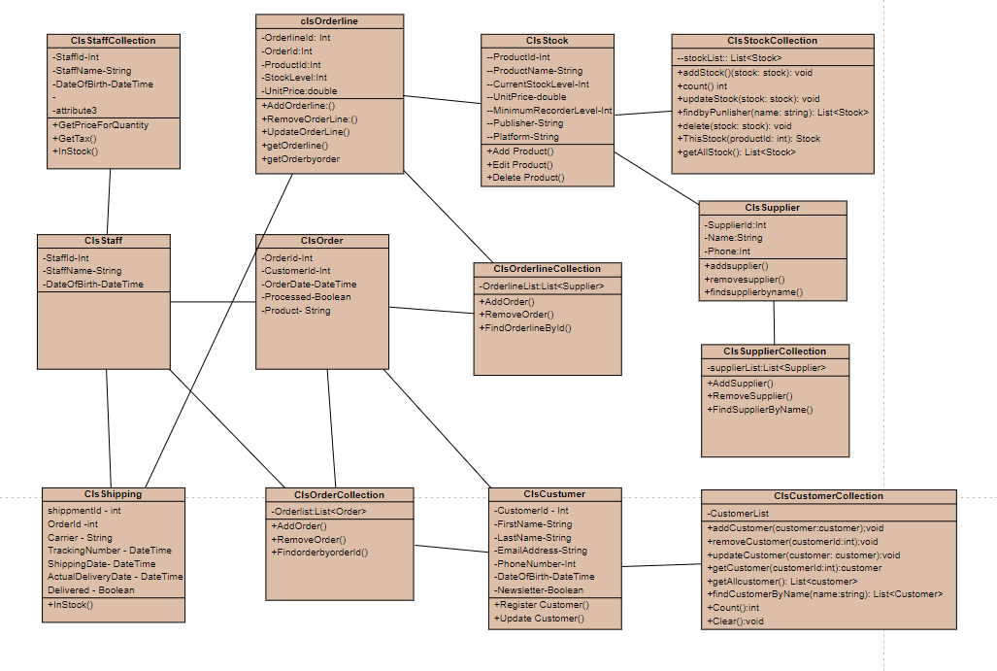

## Individual Use Case Diagram(s)

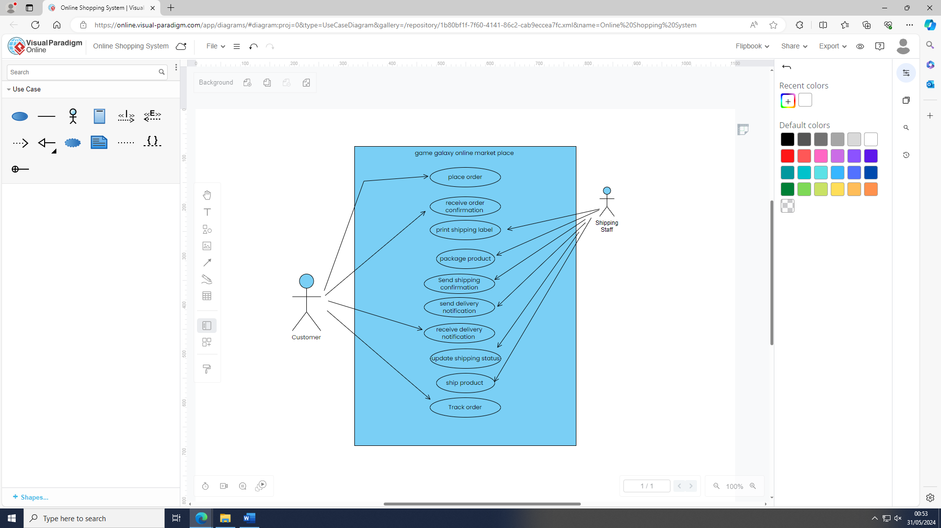Add a screenshot of your individual use case diagram(s) below.

## Individual Use Case Descriptions

Copy, paste and complete the use case description template below for each use case description.

|  |  |
| --- | --- |
| Use Case Name (Short two- or three-word name, should be the same as the use case name on diagram) | Place Order |
| Use Case Description (Short description) | A unique order ID number is generated and an email confirming the purchase is sent to the customer when they purchase a product from the online store. |
| Use Case Author(s) (Who wrote this) | Ayo |
| Actor(s) (Who does this) | Customer |
| Locations (Where does this happen) | Backend |
| Primary pathway (What is the normal “happy path” for this use case?) | The customer proceeds to checkout and provides necessary details (e.g., shipping address, payment information). |
| Alternate pathways (What other paths are there that are not the “happy path”?) | During the checkout process, the customer decides to cancel the order.so the shipment will Cancel the order request and no further action is taken. |
| Exception pathways (What could possibly go wrong?) | Notifies the customer of the payment failure and prompts for a retry or different payment method. |

|  |  |
| --- | --- |
| Use Case Name (Short two- or three-word name, should be the same as the use case name on diagram) | Receive Order Confirmation |
| Use Case Description (Short description) | The customer receives an order confirmation email after placing an order, which includes the unique order number and order details. |
| Use Case Author(s) (Who wrote this) | Ayo |
| Actor(s) (Who does this) | customer |
| Locations (Where does this happen) | Backend |
| Primary pathway (What is the normal “happy path” for this use case?) | Processes the order and confirms that it has been successfully placed. Sends an order confirmation email to the customer's email address. |
| Alternate pathways (What other paths are there that are not the “happy path”?) | The email might be delayed but still delivered.  System: The email might take longer to arrive due to network issues but eventually reaches the customer's inbox. |
| Exception pathways (What could possibly go wrong?) | Email delivery fails due to an incorrect email address or technical issues.  Attempts to resend the email or notifies the customer to check their email address.  Checks spam/junk folder if the email is not in the inbox. |

|  |  |
| --- | --- |
| Use Case Name (Short two- or three-word name, should be the same as the use case name on diagram) | Print Shipping Label |
| Use Case Description (Short description) | When an order gets to the front of the processing queue, the shipping staff prints a shipping label for the customer, including the tracking number, phone number, address, and necessary information. |
| Use Case Author(s) (Who wrote this) | Ayo |
| Actor(s) (Who does this) | Shipping staff |
| Locations (Where does this happen) | Backend |
| Primary pathway (What is the normal “happy path” for this use case?) | The shipment staff will allow the system to retrieve the next order in the queue and it prepare by collecting all the necessary details and it send it the printer and the shipment staff will collect and attach the label to the package |
| Alternate pathways (What other paths are there that are not the “happy path”?) | Gets several shipping labels ready for printing in bulk. prints several shipping labels in a row. |
| Exception pathways (What could possibly go wrong?) | Shipping staff has a problem or malfunction when printing. Alerts the shipping staff and logs the error. Tries printing the label again after solving the issue the printer issue. |

|  |  |
| --- | --- |
| Use Case Name (Short two- or three-word name, should be the same as the use case name on diagram) | Package Products |
| Use Case Description (Short description) | The shipping team properly packages the goods to guarantee their safety during transportation, making sure to include the appropriate shipping label on every box. |
| Use Case Author(s) (Who wrote this) |  |
| Actor(s) (Who does this) | Shipping staff |
| Locations (Where does this happen) | Backend |
| Primary pathway (What is the normal “happy path” for this use case?) | The shipping staff will look through their stock and once they have done that, they will update the stock count and will start to package the products carefully ensuring it protected for transit. Prints the label and attaches it to the package and then update the system to tell the customers its being package |
| Alternate pathways (What other paths are there that are not the “happy path”?) | The shipping staff will have to use protective materials when handling with fragile item and it will include on the package that you take care good care of the package |
| Exception pathways (What could possibly go wrong?) | The shipping staff could go through the inventory and the find a damage product, then they have to update the stock and order status and then replace the product if its available |

|  |  |
| --- | --- |
| Use Case Name (Short two- or three-word name, should be the same as the use case name on diagram) | Send Shipping Confirmation |
| Use Case Description (Short description) | After the package is handed over to the shipping carrier, the system automatically sends the buyer an email with a shipping confirmation, which includes updates on the delivery status. |
| Use Case Author(s) (Who wrote this) | Ayo |
| Actor(s) (Who does this) | Shipping staff |
| Locations (Where does this happen) | Backend |
| Primary pathway (What is the normal “happy path” for this use case?) | The shipping staff will be informed when the package has been giving to the shipping company and then they will make an update on the database saying “Shipped” and an email will be sent out confirming the information of the such as expected delivery date |
| Alternate pathways (What other paths are there that are not the “happy path”?) | The shipping carrier could be delayed so update on the database will have to change if the shipping company Is keeping up to date with what going within the transit of the product |
| Exception pathways (What could possibly go wrong?) | The user could have provided a wrong email address failing to send the email confirmation to the customers then you have to probably notify the administrators for help |

|  |  |
| --- | --- |
| Use Case Name (Short two- or three-word name, should be the same as the use case name on diagram) | Send Delivery Notification |
| Use Case Description (Short description) | The system automatically sends a delivery notification to the buyer once the package has been delivered, providing confirmation and updates on the delivery status. |
| Use Case Author(s) (Who wrote this) | Ayo |
| Actor(s) (Who does this) | Shipping staff |
| Locations (Where does this happen) | Backend |
| Primary pathway (What is the normal “happy path” for this use case?) | The shipment staff will be told when the package has been delivered successfully to the buyer then they will go and update the database status saying “Delivered” and an email will send to the buyer displaying that the package was delivered and any other relevant detail will be added. |
| Alternate pathways (What other paths are there that are not the “happy path”?) | The package could be delivered on the day that the buyer is not around so the package will go back to the shipping depot and wait until it is rescheduled. |
| Exception pathways (What could possibly go wrong?) | The shipment staff could bump into in error when trying to update the status of the package or probably sending an email |

|  |  |
| --- | --- |
| Use Case Name (Short two- or three-word name, should be the same as the use case name on diagram) | Track Order |
| Use Case Description (Short description) | The system allows the buyer and seller to track the status and location of an order throughout the shipping process, providing updates on the order's progress. |
| Use Case Author(s) (Who wrote this) | Ayo |
| Actor(s) (Who does this) | Shipping staff  Customer |
| Locations (Where does this happen) | Backend |
| Primary pathway (What is the normal “happy path” for this use case?) | the customer will visit the order tracking page and input the tracking number provide in emails and the system will display the status and the tracking details. |
| Alternate pathways (What other paths are there that are not the “happy path”?) | The customer could enter the wrong tracking number or the database could not find the because the tracking number hasn’t been provided |
| Exception pathways (What could possibly go wrong?) | The tracking number is missing or currently not available and the database will display that information you are currently looking for is unavailable and should check back later |

|  |  |
| --- | --- |
| Use Case Name (Short two- or three-word name, should be the same as the use case name on diagram) | Ship Product |
| Use Case Description (Short description) | When a customer places an order, the system starts the shipping process, which includes creating shipping labels, packing the item, and giving it to the shipping carrier to be delivered. |
| Use Case Author(s) (Who wrote this) | Ayo |
| Actor(s) (Who does this) | Shipping staff |
| Locations (Where does this happen) | Backend |
| Primary pathway (What is the normal “happy path” for this use case?) | The shipping staff will be alerted when it’s time to ship a package after all the necessary information has been provided such as the shipping label that contain the customer information and the make suer the package and protected for transit and then get ready to hand it over to the shipping company |
| Alternate pathways (What other paths are there that are not the “happy path”?) | The product could be temporarily out of stock so the shipping staff will have to hold the order until its back in stock |
| Exception pathways (What could possibly go wrong?) | When create the label the incorrect detail could have been entered so the shipping staff will have to checks and correct them so no errors are made |

# Ethics Case Study

## Risk Register

Risk Assessment

|  |  |
| --- | --- |
| H | High-unacceptable risk; major disruption likely; different approach required; priority management attention required. |
| M | Moderate risk; some disruption; different approach may be required; additional management attention. |
| L | Low/minimum risk; minimum oversight needed to ensure risk remains low |

Scoring: IMPACT LIKELIHOOD (L)

1 = Insignificant 1 = Rare

2 = Minor 2 = Unlikely

3 = Moderate 3 = Possible

4 = Major 4 = Likely

5 = Catastrophic 5 = Almost Certain

## Ethics Checklist

|  |  |  |  |
| --- | --- | --- | --- |
| **Risk** | **Likelihood** | **Impact** | **Proposed risk-mitigation measure** |
| Payment Processing Errors: | 3m | 5H | Offer instructions for resolving common payment issues, such as verifying card details or using alternative payment methods. |
| Stock Management Errors: | 4m | 4M | Make sure employees and clients have access to correct stock information so they can make the right decisions |
| Problems with user login or account creation. | 3m | 5H | Provide an option for the customer that will allow the user to recover or rest they password or set security question |
| Errors when users try to review or modify orders. | 3M | 2M | Provide clear error messages that explain the problem and offer guidance on how to resolve it. |
| Issues with third-party services like payment gateways or shipping providers | 4m | 4H | Maintain open communication channels with third-party service providers to stay informed about service updates, maintenance schedules, and potential issues. |
| Mismanagement of User Feedback: | 2m | 3M | Provide multiple channels for users to submit feedback, including online forms, email, chat support. |
| Errors in processing orders, leading to delays or mistakes. | 4m | 4M | Provide accessible customer support channels for inquiries, order modifications, or resolution of order-related issues. |
| Fraudulent Transactions | 5m | 5M | Require users to enter a one-time password or use biometric authentication for additional security verification. |

|  |  |  |
| --- | --- | --- |
| **Key Principle** | **Rationale** | **How has it been addressed or could be addressed** |
| Transparency: Transparency is essential in the development of ethical software. | This means users should understand how their data is collected, processed, and stored. As a developer, you should offer clear and accessible documentation regarding your software’s capabilities, limitations, and potential risks. This openness creates trust between developers and users, allowing them to make informed decisions about their data and engagement with the platform. | Within the shipment management for our online video games marketplace transparency needs clear information and communication about the order that being processed, tracked, delivery. After purchase, each order is assigned a unique order number that is shared via email. Customers are kept informed at every stage of the shipping process by receiving regular updates, which include shipping confirmation and delivery notifications. Shipping labels are created using personal information from customers, including name, address, and phone number, to ensure proper delivery. When registering for an account or placing an order, customers are notified about the collection and use of this data. The website has simple to access documentation that details the steps to take for collecting, using, and safely storing this data. Through their account, customers can access their personal information, order history, and review and modify their orders. Customers will be able to know what data is stored and how it is used thanks to this transparency. After an order is placed, processed, shipped, and delivered, customers are notified and These updates help manage expectations and reduce uncertainty about delivery timelines. |
| Privacy: Privacy is a fundamental right software must respect. | As a developer, you should only collect the data required for your application’s intended purpose following the data minimization principles and acquire informed consent from users. | privacy should be handled with caution as we handle sensitive customer information like complete names, addresses, and phone numbers. We make sure that the information we collect is used for the intended purpose and that it is necessary. Customers will be notified about the data we collect and why. once they have created an account or placed an order. Additionally, customers will have the ability to update their personal data. They will be able to maintain their data current as a result. Before the customer can complete their order, they will have to agree to the terms and privacy policy this will allow us to use the customer personal information for order processing and shipping updates. The user will have a safe experience because the shipping management complies with the data protection principles. |
| Security: In ethical software development, security is paramount | Software should be planned and produced throughout the development lifecycle, with security a high concern. Developers should follow best practices to identify, avoid, and mitigate vulnerabilities. | Ensuring that all customer data, including full names, addresses, and phone numbers, is shielded from unwanted access and potential breaches is crucial for the Shipping Management component. This is identifying, preventing, and mitigating vulnerabilities throughout the development the life cycle by following to best practices. Within the system only authorized personnel so whoever is working int shipping management should have access to sensitive information. When customers want to sign in their will use their secure login to access the account and order details so additional security will have to be added to provide extra layer of security for customers and staff. |
| Fairness: Fairness ensures that software does not discriminate against any group or individual. | Algorithms and decision-making processes should be free of bias and not increase or perpetuate social and economic imbalances. Developers must use approaches to discover and reduce biases in algorithms and data. | Our system makes sure that every customer has access to the same shipping options, no matter where they are in the world.  First-come, first-served policy applies to order processing. This makes sure that no customer receives special consideration over another because of their location, the size of their order, or any other unimportant factor. Every customer will get the same updates and messages at every stage of the shipping procedure. Standard notifications, like shipping confirmations and delivery updates.  All users have equal access to customer support. All complaints about shipping are handled quickly and fairly, guaranteeing that everyone is treated fairly.by putting these measures in place it should strive to maintain fairness and equity by making sure that customers receive the same type of service, this will enable trust. |
| Accountability: The effects of software on people and society are the responsibility of its developers. | As developers, we must be accountable for any unfavourable outcomes and be open and honest about growth procedures. Clear methods for reporting ethical concerns should be established, and any ethical issues should be addressed as soon as possible | We keep detailed records of every stage of our shipping process, from processing orders and creating labels to tracking packages. All personnel who need access to it can access this documentation, making sure consistency and accountability. In order to support our ongoing improvement and dedication to providing high-quality service, we regularly review our shipping procedures in order to spot and address any potential problems. Employees in the shipping section are trained in ethical and responsible behaviour. They are sure to understand the significance of following system integrity and gaining clients' trust thanks to this training. |

<https://blog.openreplay.com/ethical-considerations-in-software-development/>

# References

When you have finished adding your work to this template, go to the contents list on page 2, hover over the word ‘Contents’ and select ‘Update Entire Table’. This will update the page numbers and headings. Then delete all notes in red before submitting.